MECHTRON 4AA4

Lab 3 Report

Adam Bujak – 400113347

Harneet Singh – 400110275

Part 1. 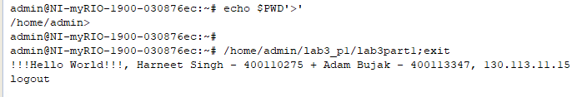

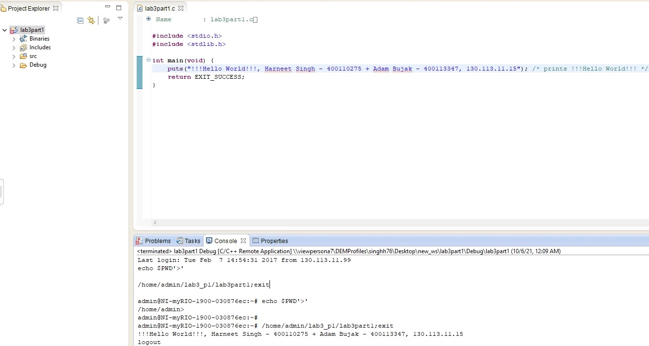

Part 2.

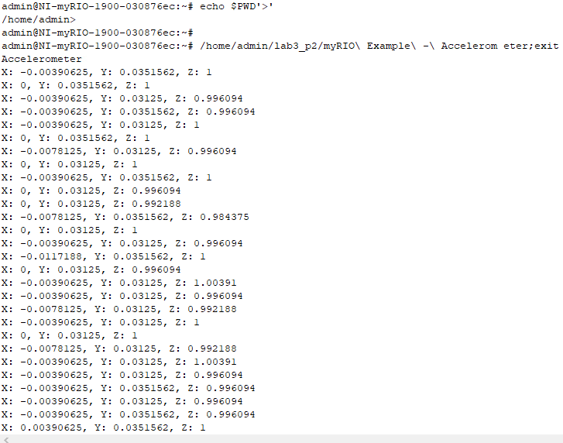

Part 3.

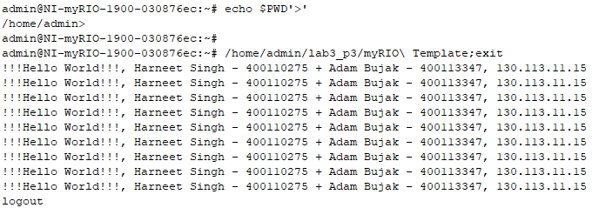

Part 4.

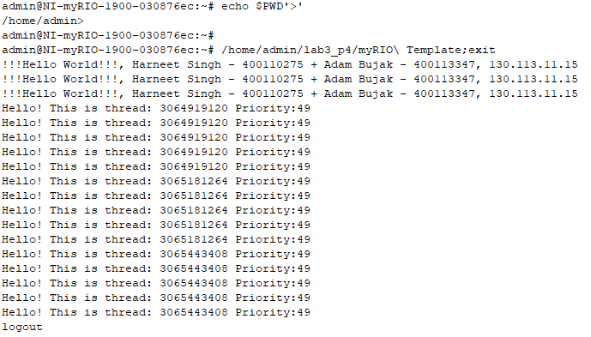

Report

1. **Explain the purpose of functions: sched_setscheduler(), mlockall() and stack_prefault()**

The purpose of sched_setscheduler is to set the specified process’ scheduling policy. The supported options are SCHED_OTHER, SCHED_BATCH, SCHED_IDLE, SCHED_FIFO, and SCHED_RR.

The purpose mlockall() is to prevent page faults by locking the process’ memory in RAM and not allowing it to be moved to the swap (secondary memory emulating RAM), as this is a slow operation since secondary memory is slow.

The purpose of stack_prefault() is to prefault the entire memory of the process. This means to move any of the process’ data stored in the swap area to the primary memory. By accessing every memory address, we force anything stored in secondary memory to be brought back into primary memory.

1. **We used a function clock_gettime(CLOCK_MONOTONIC ,&t), where t is struct of type timespec. Give details of the struct timespec and explain the meaning of CLOCK_MONOTONIC.**

The struct timespec has the following structure:

struct timespec {

time_t tv_sec; /* seconds */

long tv_nsec; /* nanoseconds */

};

So, by calling clock_gettime(CLOCK_MONOTONIC, &t) the function sets our local t variable’s seconds and nanoseconds fields. The CLOCK_MONOTONIC field indicates to the clock_gettime() function that we want the time elapsed from some fixed point in time which can never be changed. This is useful because we know that if we are comparing CLOCK_MONOTONIC times they will always be compared to a fixed point in time and won’t be changed by some other process.

1. **What is the time period of this task? How can you assign a time period of 20ms to this task?**

Since the interval is 50,000,000 this corresponds to 50,000,000ns which makes the time period 50ms. To make the time period 20ms we should set int interval = 20000000;

1. **Explain the purpose of the function sched_setaffinity() and its parameters.**

A CPU affinity mask is a number that indicates on which CPUs a process should run. The sched_setaffinity() function sets the specified process’ CPU affinity mask.

int sched_setaffinity(pid_t pid, size_t cpusetsize,

const cpu_set_t *mask);

|  |  |
| --- | --- |
| Parameter | Description |
| pid | The process ID of the process whose cpu affinity the user wishes to modify |
| cpusetsize | The size of the mask the user is specifying in bytes |
| mask | Pointer to the mask which the user wishes to set.  ie if the user whishes to use CPUs 0 and 2 the user would do the following:  cpu_set_t mask = 0x5;  sched_setaffinity(PID, sizeof(cpu_set_t), &mask); |

1. **Explain the purpose of the function pthread_create() and its parameters.**

pthread_create() is used to create a new thread in the current process.

int pthread_create(pthread_t *restrict thread,

const pthread_attr_t *restrict attr,

void *(*start_routine)(void *),

void *restrict arg);

|  |  |
| --- | --- |
| Parameter | Description |
| thread | Once the thread is created the thread ID is stored in this pointer |
| attr | Pointer to a structure that specifies some configuration options for the thread |
| start_routine | The function which is executed once the thread starts |
| arg | Some value the user wishes to be passed to the start_routine |